UCS1412 – Database Lab

Mini Project

Pharmacy management system

Done by

Abhishek K (185001005)

Gokhulnath T (185001051)

Hemanth Kumar K M (185001059)

1) Abstract

Pharmacy management system is a management system that is designed to improve accuracy and to enhance safety and efficiency in the pharmaceutical store. This program can be used in any pharmaceutical shops having a database to maintain. It is a computer-based system which helps the pharmacist to improve inventory management, cost, medical safety etc. The system allows the user to enter a manufacturing and expiry date for a particular product or drug during opening stock and sales transaction. The software can print invoices, bills, receipts etc. It can also maintain the record of supplies sent in by the supplier. The system services and goals are established by consultation with system user. It also involves manual entry upon arrival of new batches of drugs and upon drug movement out of the pharmacy for a certain period. Pharmacy management system deals with the maintenance of drugs and consumables in the pharmacy unit. The main aim of the project is to manage the database of a pharmaceutical shop. This project provides insight into the design and implementation of a Pharmacy Management System. It is done by creating a database of the available medicines and equipment in the shop. The primary aim of pharmacy management system is to improve accuracy and enhance safety and efficiency in the pharmaceutical store and to develop software for its effective management. Pharmacy management system is useful to maintain correct database by providing an option to update the drugs in stock and is used to manage most pharmacy related activities.

2) ENTITY-RELATIONSHIP DIAGRAM

ER Diagram for this project consists of 9 regular entities and 3 relational/associative

entities. The regular entities are:

1: PHARMACY

2: CUSTOMER

3: DOCTOR

4: MANUFACTURER

5: MEDIQUIPMENT

6: EMPLOYEE

7: HOSPITAL

8: BILL

9: SUPPLIER

The associative entities are:

1: PRESCRIBE

2: CONTRACT

3: WORKS

The attributes of each of these entities are:

1: PHARMACY {PHID, NAME, CITY, FAX, PHONE} where PHID is primary key.

Pharmacy Management System

Dept of ISE, BNMIT 2017-18 Page | 4

2: CUSTOMER {PID, NAME, SEX, CITY, PHONE, AGE, DID} where PID is primary

key and DID is foreign key.

3: DOCTOR {DID, DNAME, SPECIALITY, AGE, MOBILE, GENDER} where DID is

primary key.

4: MANUFACTURER {CID, NAME, EMAIL, MOBILE, CITY, PHARID} where CID

is primary key and PHARID is foreign key.

5: MEDIQUIPMENT {CODE, TRADE_NAME, PRODUCT_TYPE, MFG_DATE,

EXP_DATE, PRICE, CID} where CODE is primary key and CID is foreign key.

6: EMPLOYEE {NAME, CITY, DOJ, MOBILE, SALARY, AGE, SEX, PHARID}

where MOBILE is primary key and PHARID is foreign key.

7: HOSPITAL {HID, NAME, EMAIL, PHONE, CITY, PHARID} where HID is primary

key and PHARID is foreign key.

8: BILL {BID, DOB, AGE, PNAME, MOBILE, CITY, PRODUCT, AMOUNT,

PHARID} where BID is primary key.

9: SUPPLIER {NAME, CITY, MOBILE, EMAIL, CID, PHARID} where MOBILE is

primary key and CID, PHARID is foreign key.

10: PRESCRIBE {DATE, MEDICINE, DID, PID} where DID, PID is foreign key.

11: CONTRACT {PHARID, CID, START_DATE, END_DATE} where PHARID, CID

is foreign key.

12: WORKS {PHARID, START_DATE, END_DATE} where PHARID is foreign key.

**ER Diagram of Pharmacy Management System**



PHARMACY

PHONE

FAX

CITY

NAME

PHID

DOCTOR



CUSTOMER

|  |  |  |  |  |  |
| --- | --- | --- | --- | --- | --- |
| DID | DNAME | SPECIALITY | AGE | MOBILE | GENDER |

DID

AGE

PHONE

CITY

SEX

NAME

PID

MANUFACTURER

PHARID

CITY

MOBILE

EMAIL

NAME

CID

|  |  |  |  |  |  |  |  |
| --- | --- | --- | --- | --- | --- | --- | --- |
| MEDIQUIPMENT | | | | | | |  |
| CODE | TRADE_NAME | PRODUCT_TYPE | MFG_DATE | EXP_DATE | PRICE | CID | |

SUPPLIER

PHARID

CID

EMAIL

MOBILE

CITY

NAME

EMPLOYEE

PHARID

SEX

AGE

SALARY

MOBILE

DOJ

CITY

NAME

HOSPITAL

PHARID

CITY

PHONE

EMAIL

NAME

HID

BILL

PHARID

AMOUNT

PRODUCT

CITY

MOBILE

PNAME

AGE

DOB

BID

WORKS

END_DATE

START_DATE

PHARID

CONTRACT

END_DATE

START_DATE

CID

PHARID

PRESCRIBE

PID

DID

MEDICINE

DOP

**Relational Database Schema for Pharmacy Management System**

KEY ATTRIBUTES

|  |  |  |
| --- | --- | --- |
| ENTITY | PRIMARY KEY | FOREIGN KEY |
| PHARMACY | PHID |  |
| DOCTOR | DID |  |
| CUSTOMER | PID | DID |
| MANUFACTURER | CID | PHARID |
| MEDIQUIPMENT | CODE | CID |
| SUPPLIER | MOBILE | CID, PHARID |
| EMPLOYEE | MOBILE | PHARID |
| HOSPITAL | HID | PHARID |
| BILL | BID | PHARID |
| WORKS | PHARID | PHARID |
| CONTRACT | PHARID, CID | PHARID, CID |
| PRESCRIBE | PID, DID | DID,PID |

SNAPSHOTS

1)Login Page :-

This page asks the user to enter the username and password to login into the system.

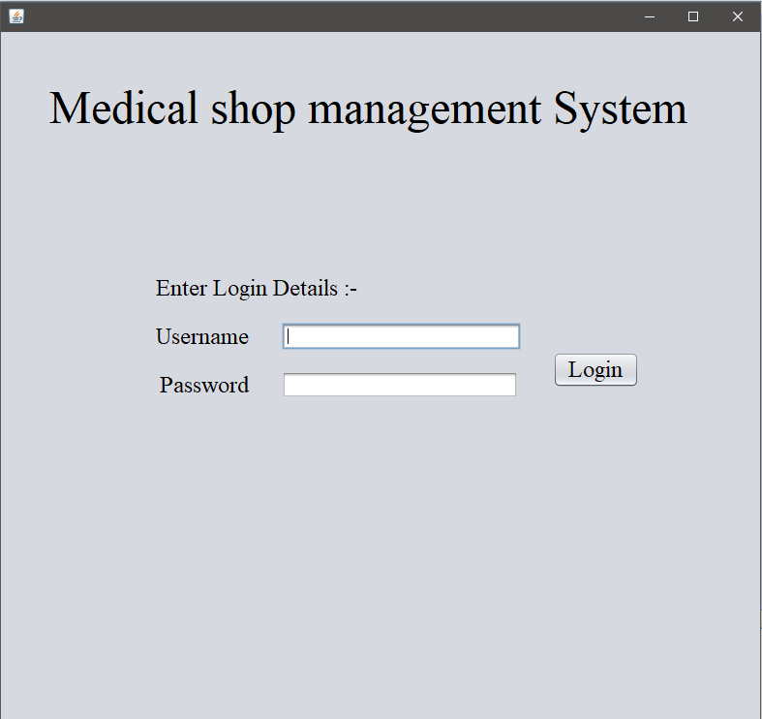

2)Option Page :-

This page lets the user select from the different options available in the form.

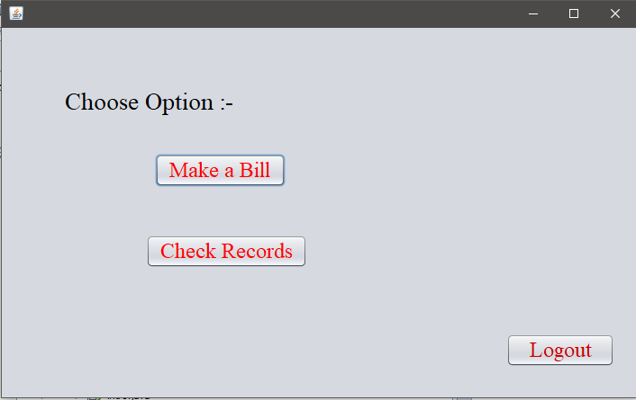

3)Billing Page :-

This page allows the user to generate a bill and save the bill, once all the data that are asked in the form are inserted.

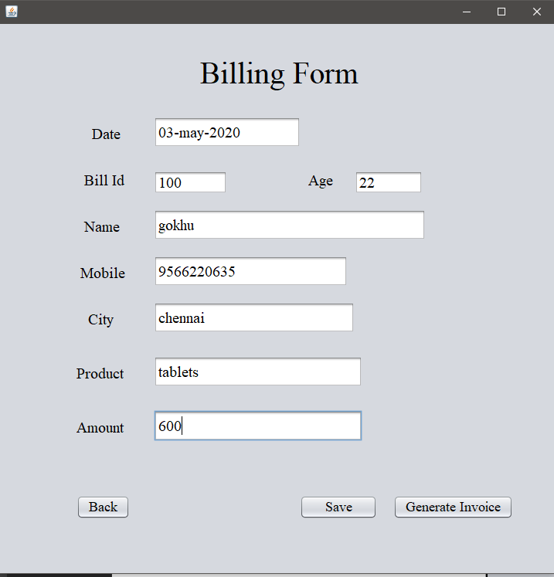

4)Bill Invoice Page :-

This page displays all the data that the user has entered in the billing page.

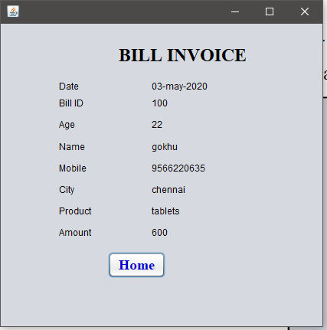

5)Category Page :-

This page displays the different categories that are available in the system and are connected to the database.

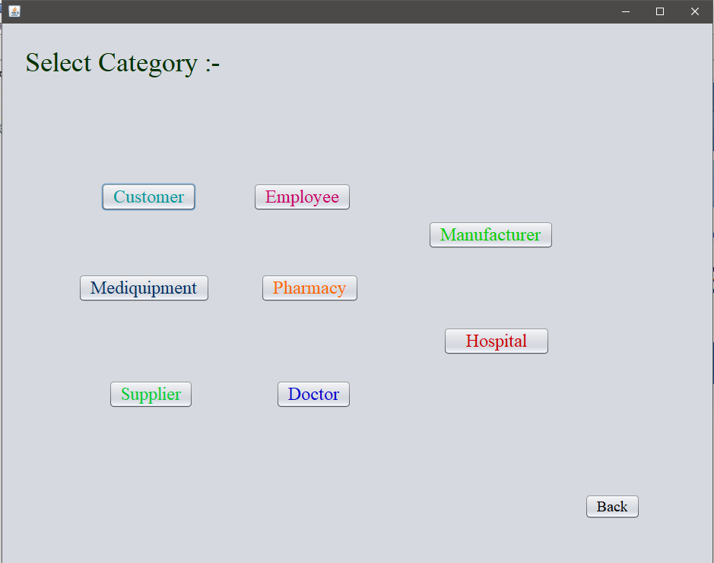

6)Pharmacy Page :-

This page lets the user to insert data into the database from the front end, delete the data that the user wants to delete and view the database that is stored in the database.

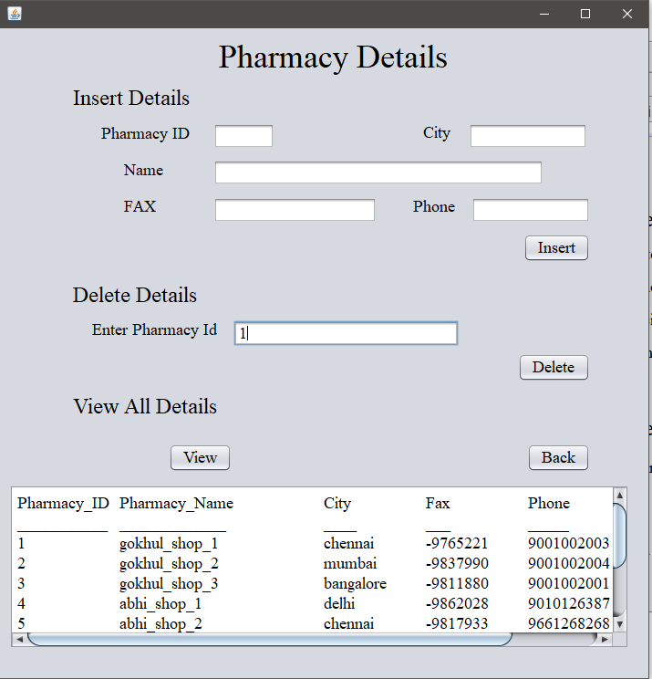

After deletion,

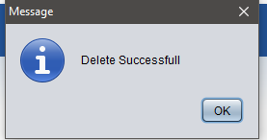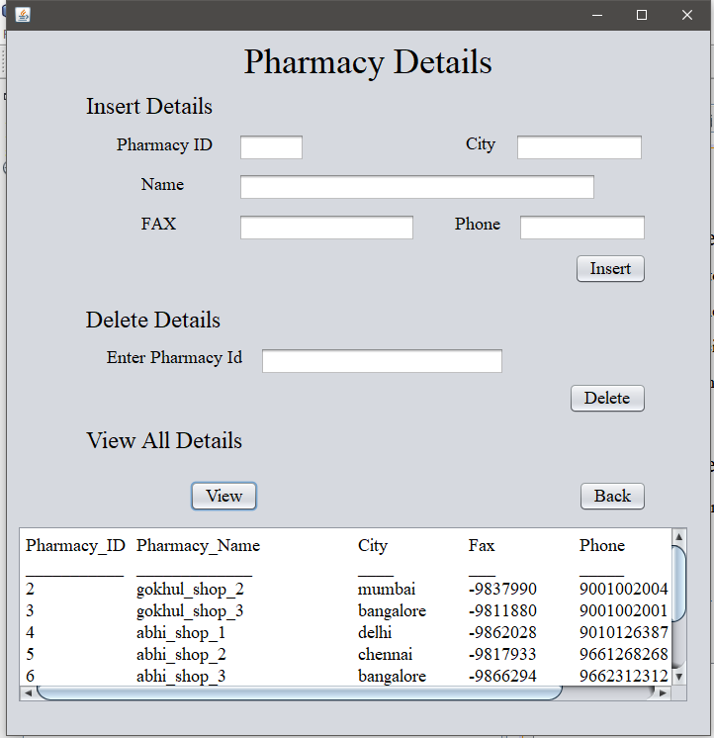

Inserting the details,

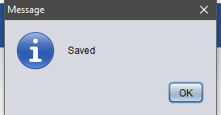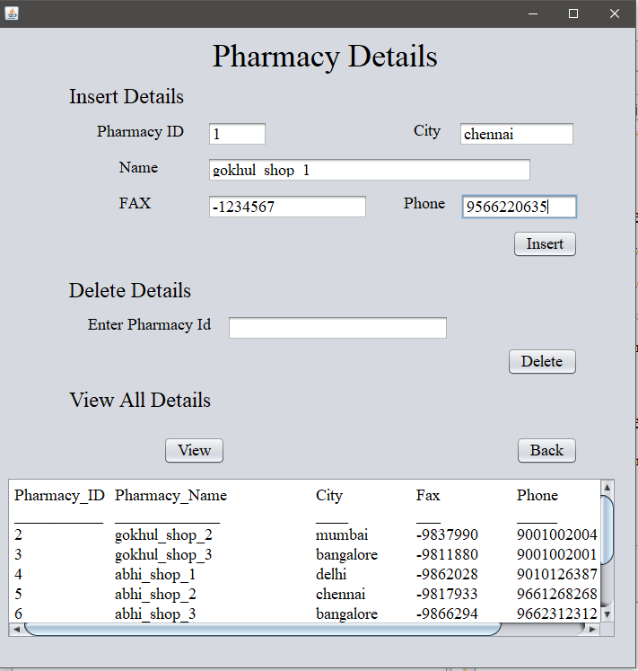

7)Doctor Page :-

This page lets the user to insert data into the database from the front end, delete the data that the user wants to delete and view the database that is stored in the database.

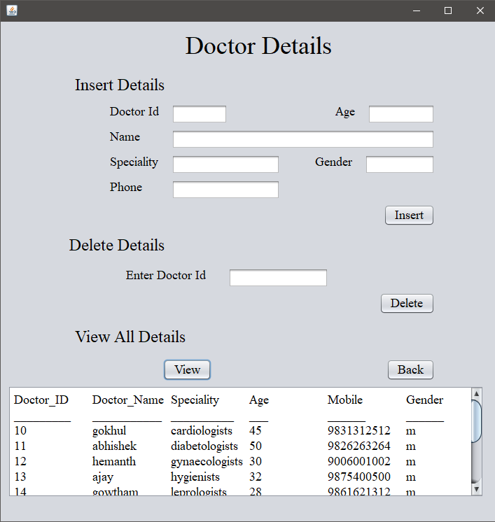

After deletion,

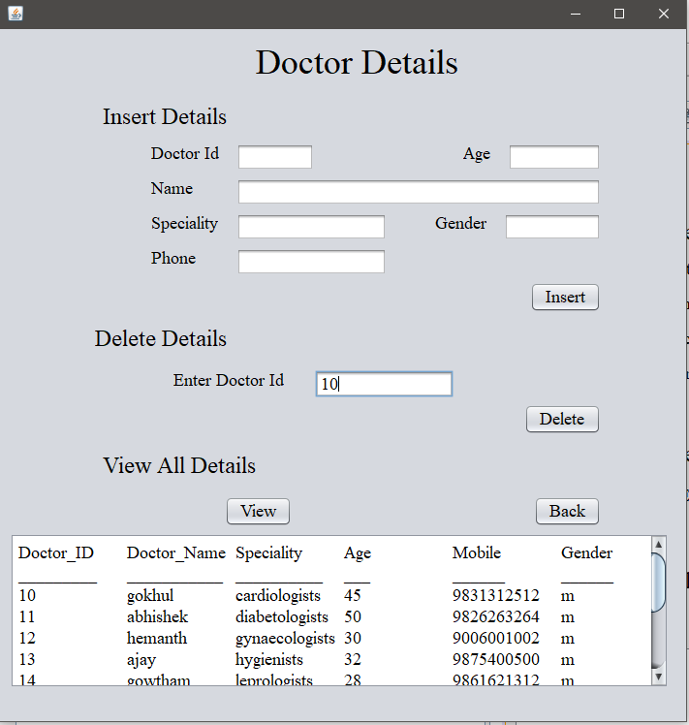

Inserting the details,

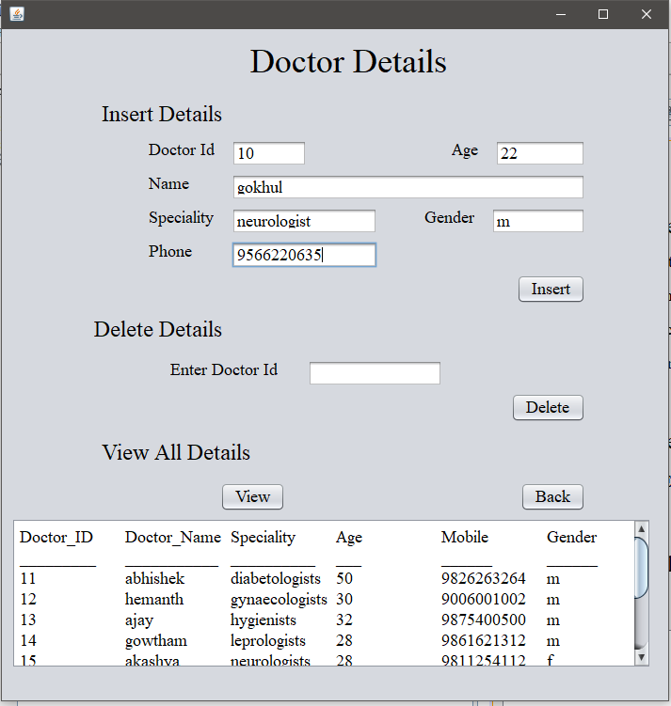

8)Customer Page :-

This page lets the user to insert data into the database from the front end, delete the data that the user wants to delete and view the database that is stored in the database.

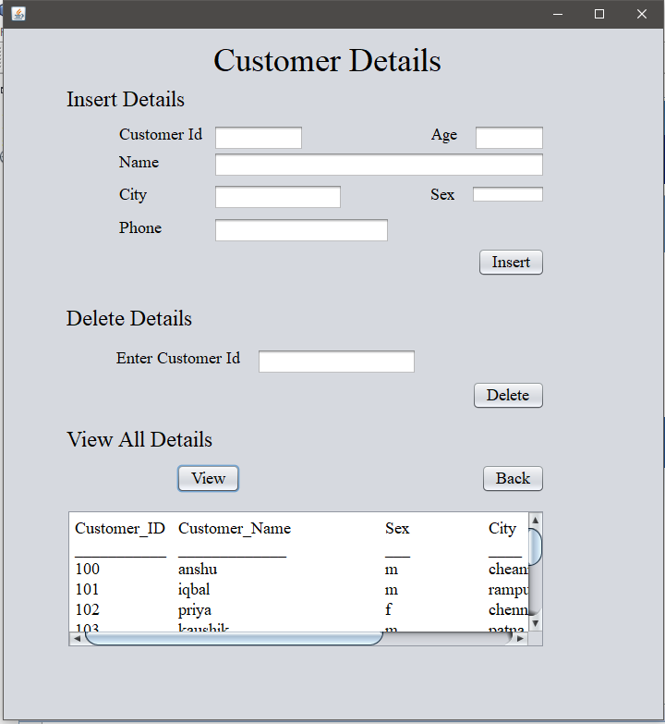

After deletion,

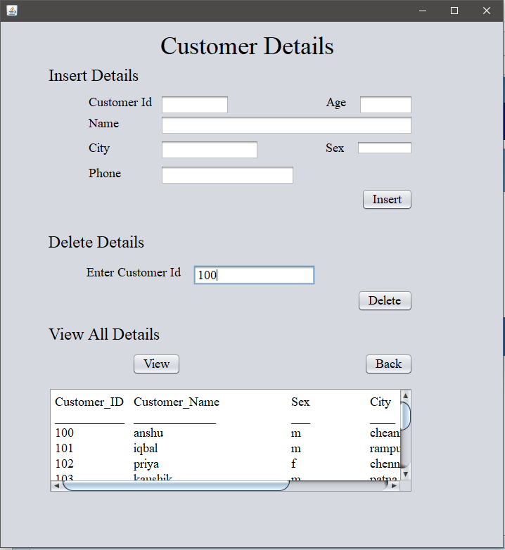

Inserting the details,

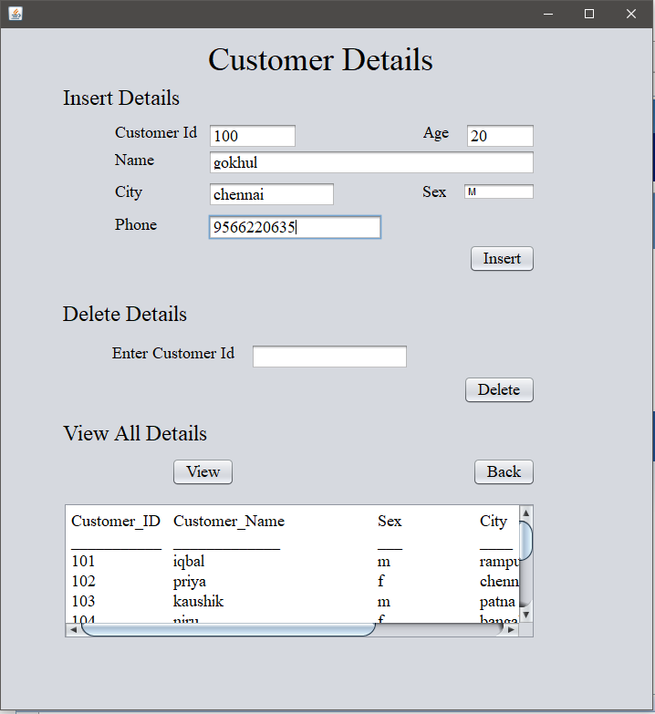

9)Manufacturer Page :-

This page lets the user to insert data into the database from the front end, delete the data that the user wants to delete and view the database that is stored in the database.

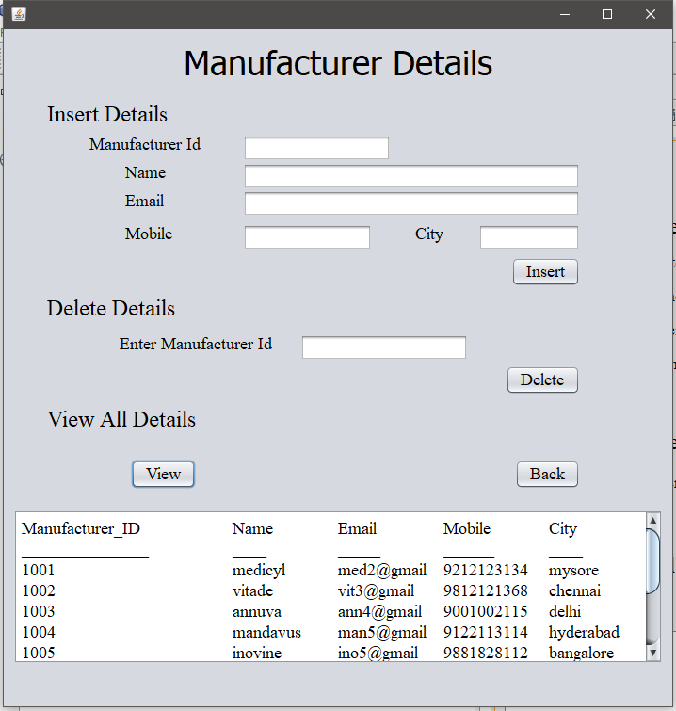

After deletion,

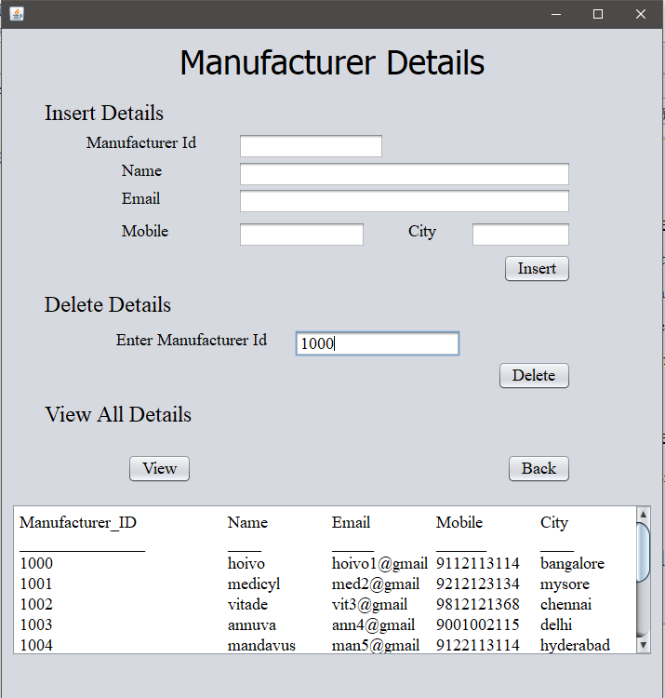

Inserting the details,

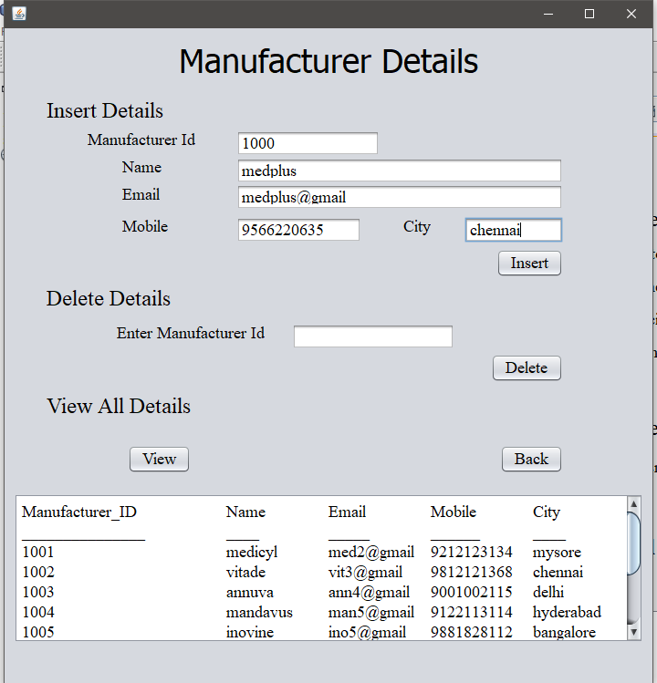

10)Mediquipment Page :-

This page lets the user to insert data into the database from the front end, delete the data that the user wants to delete and view the database that is stored in the database.

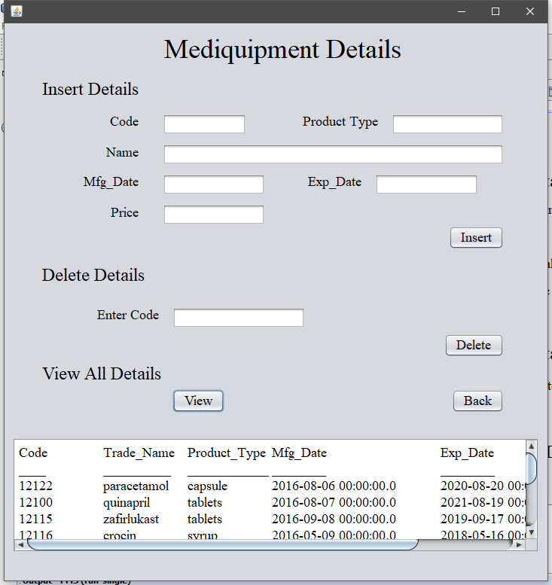

After deletion,

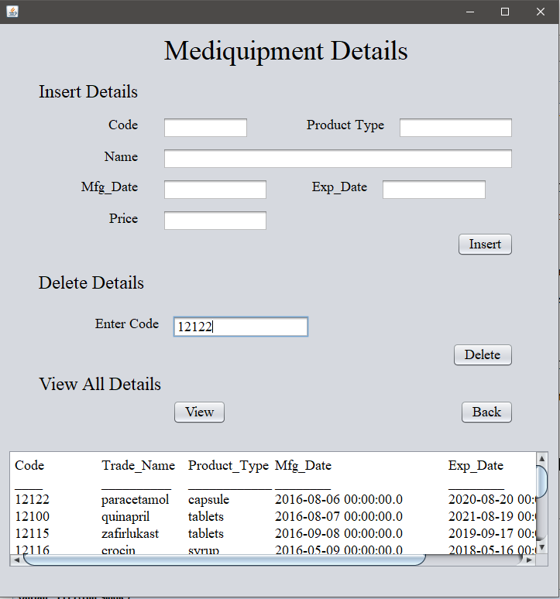

Inserting the details,

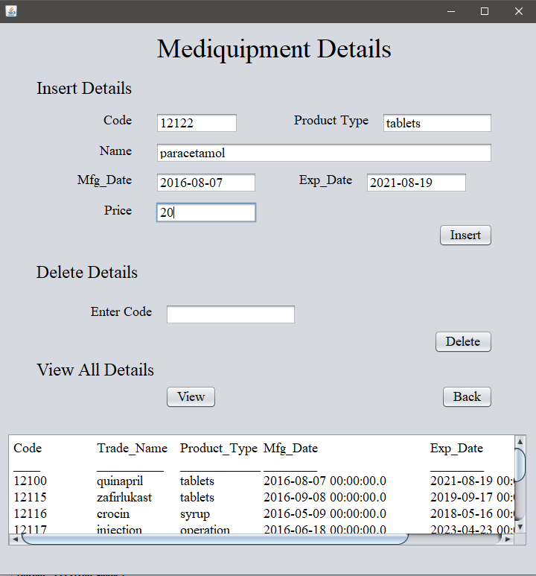

11)Employee Page :-

This page lets the user to insert data into the database from the front end, delete the data that the user wants to delete and view the database that is stored in the database.

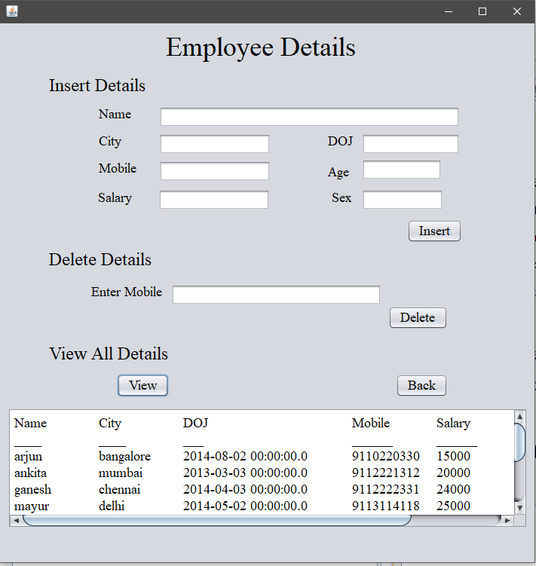

After deletion,

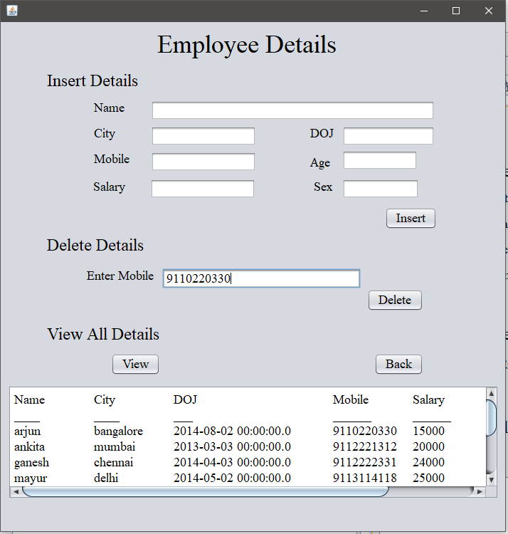

Inserting the details,

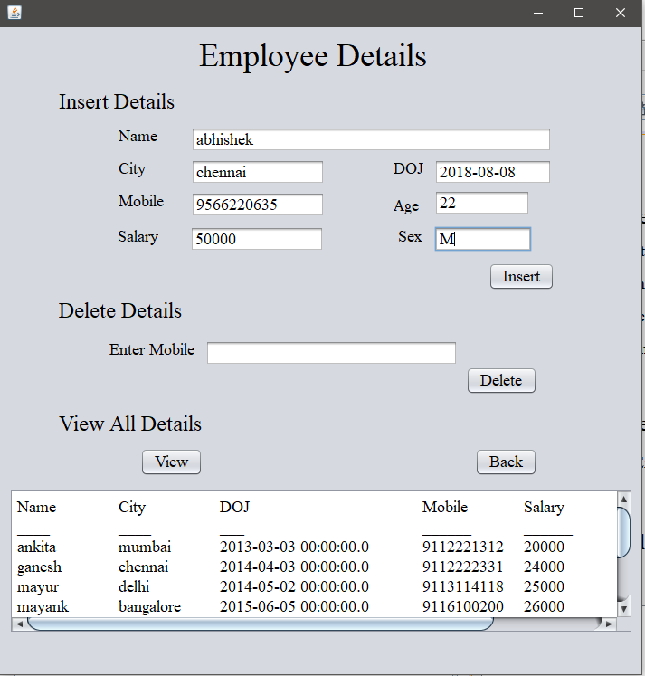

12) Supplier Page :-

This page lets the user to insert data into the database from the front end, delete

the data that the user wants to delete and view the database that is stored in the

database.

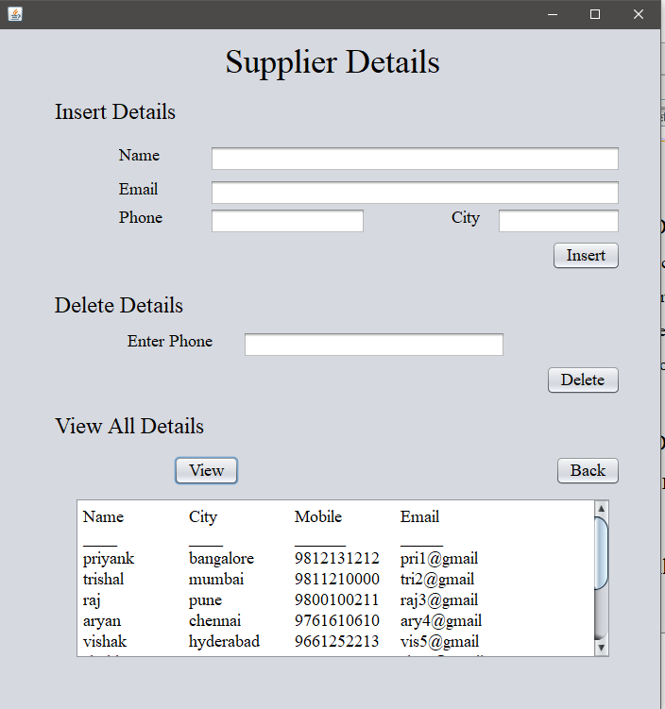

13) Hospital Page :-

This page lets the user to insert data into the database from the front end, delete

the data that the user wants to delete and view the database that is stored in the

database.

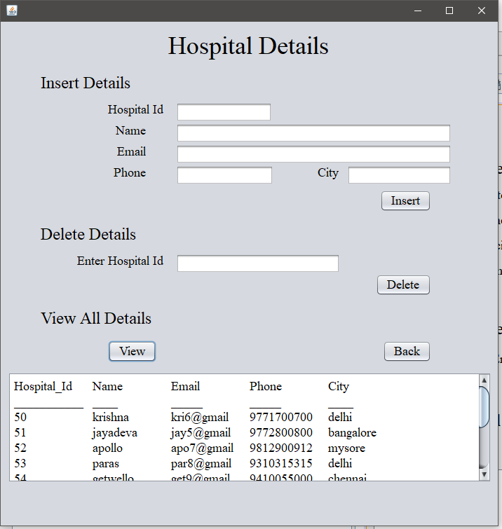

SQL QUERY

1. This query displays the name and salary of all employee’s whose salary is greater than the average salary of all employee’s working in Bangalore.

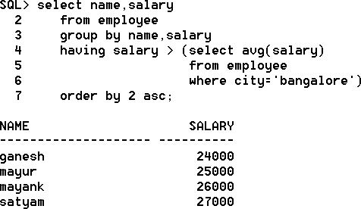

1. This query updates the medicine’s price in mediquipment table to 300, if the manufacturer is from Pune.

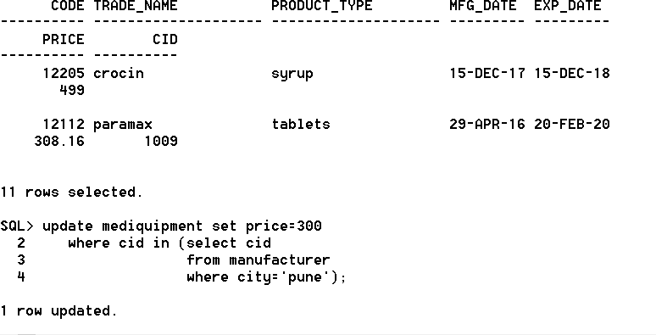

(Before execution)

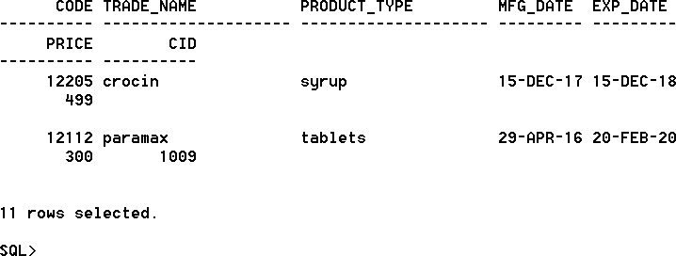

(After execution)

1. This query displays the name of pharmacy, pharmacy id and the count of the manufacturer id, if a pharmacy is taking medicine’s from more than one manufacturer.

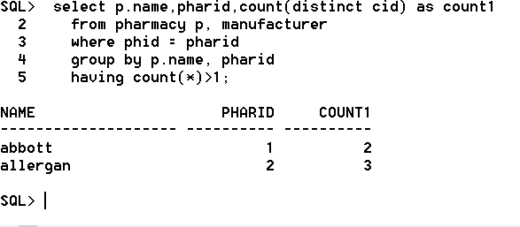

1. This query displays the pharmacy name, employee name and employee salary, who are working in a pharmacy except the female employee.

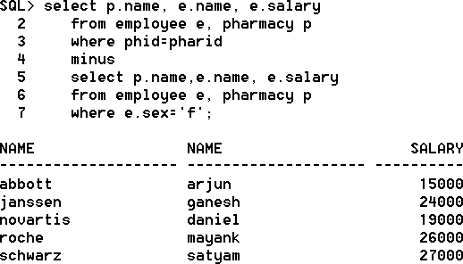

**PROCEDURE :-**

This procedure update’s the medicine price by 100 in the mediquipment table, where the trade name is paramax.

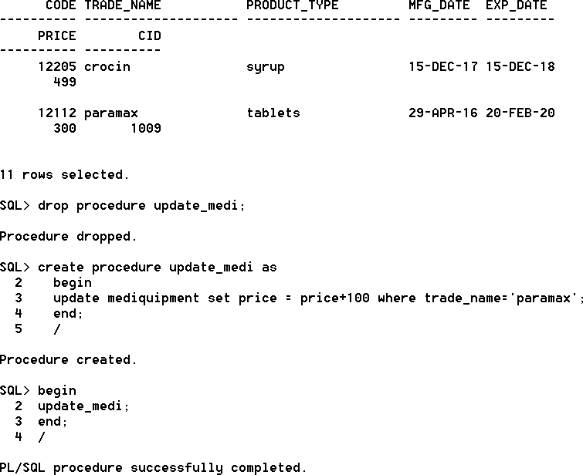

(Before procedure is executed)

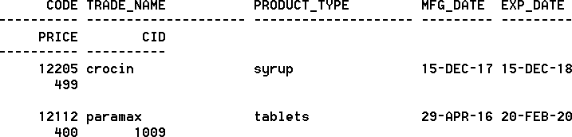

(After procedure is executed)

Triggers:

1. This trigger will change the price of a medicine to 499, if the price is greater than 500.

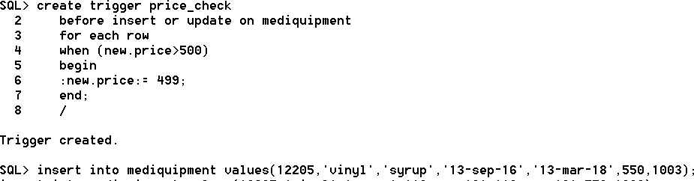

(Trigger is executed and a insertion is performed)

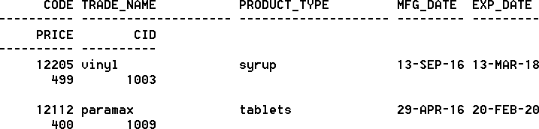

(Inserted price is less than 500)

1. This trigger will display a message if the age of a doctor is greater than 80.

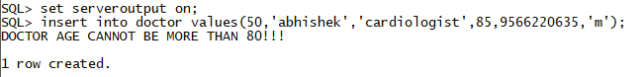

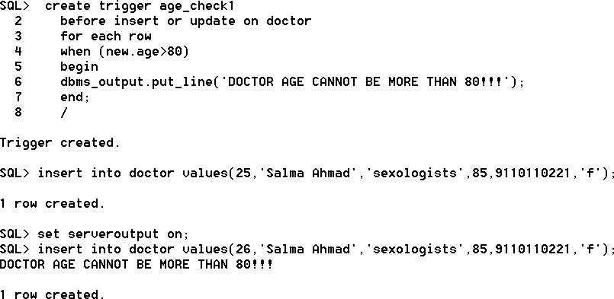

**Database creation commands**

**Connection commands:**

connect system/gokhul;

create user medicalshop22 identified by gokhul;

grant connect, resource to medicalshop22;

connect medicalshop22/gokhul;

@ C:\Users\gokhu\Desktop\pharmacy.sql

Database commands:

create table pharmacy

(

phid integer primary key,

name varchar2(20),

city varchar2(20),

fax varchar2(20),

phone number(10));

create table doctor

(

did number(2) primary key,

dname varchar2(20),

speciality varchar2(20),

age number(2) not null,

mobile integer,

gender varchar2(6));

create table customer

(

pid number(3) primary key,

name varchar2(20),

sex varchar2(6),

city varchar2(20),

phone integer,

age number(2),

did references doctor(did) on delete set null);

create table manufacturer

(

cid number(4) primary key,

name varchar2(20),

email varchar2(20),

mobile integer,

city varchar2(20),

pharid references pharmacy(phid) on delete set null);

create table mediquipment

(

code number(5) primary key,

Trade_name varchar2(20),

Product_Type varchar2(20),

Mfg_date date,

Exp_date date,

price number(10,2),

cid references manufacturer(cid) on delete set null);

create table supplier

(

name varchar2(20),

city varchar2(20),

mobile integer primary key,

email varchar2(20),

cid references manufacturer(cid) on delete set null,

pharid references pharmacy(phid) on delete set null);

create table employee

(

name varchar2(20),

city varchar2(20),

doj date,

mobile integer primary key,

salary number(10),

age number(2),

sex varchar2(1),

pharid references pharmacy(phid) on delete set null);

create table hospital

(

hid number(2) primary key,

name varchar2(20),

email varchar2(40),

phone integer,

city varchar2(20),

pharid references pharmacy(phid) on delete set null);

create table bill

(

bid number(3) primary key,

DOB date,

age number(3),

pname varchar2(20),

mobile integer,

city varchar2(20),

product varchar2(20),

amount number(10,2),

pharid references pharmacy(phid) on delete set null);

create table works

(

pharid references pharmacy(phid) on delete cascade,

start_date date,

end_date date,

primary key(pharid));

create table contract

(

pharid references pharmacy(phid) on delete cascade,

cid references manufacturer(cid) on delete cascade,

start_date date,

end_date date,

primary key(pharid,cid));

create table prescribe

(

DOP date,

medicine varchar2(20),

did references doctor(did) on delete cascade,

pid references customer(pid) on delete cascade,

primary key(pid,did));

select name,salary

from employee

group by name,salary

having salary > (select avg(salary)

from employee

where city='bangalore')

order by 2 asc;

update mediquipment set price=300

where cid in (select cid

from manufacturer

where city='pune');

select p.name,pharid,count(distinct cid) as count1

from pharmacy p, manufacturer

where phid = pharid

group by p.name, pharid

having count(*)>1;

select p.name, e.name, e.salary

from employee e, pharmacy p

where phid=pharid

minus

select p.name,e.name, e.salary

from employee e, pharmacy p

where e.sex='f';

create procedure update_medi as

begin

update mediquipment set price = price+100 where trade_name='paramax';

end;

/

create trigger price_check

before insert or update on mediquipment

for each row

when (new.price>500)

begin

:new.price:= 499;

end;

/

create trigger age_check1

before insert or update on doctor

for each row

when (new.age>80)

begin

dbms_output.put_line('DOCTOR AGE CANNOT BE MORE THAN 80!!!');

end;

/

commit;

Application Code

1. Biling Page:

private void InsertActionPerformed(java.awt.event.ActionEvent evt) {

// TODO add your handling code here:

try{Class.forName("oracle.jdbc.OracleDriver");

Connection con1=DriverManager.getConnection("jdbc:oracle:thin:@DESKTOP-C3RN1T1:1521:XE","medicalshop22"," gokhul");

String sql="Insert into bill(bid,dob,age,pname,mobile,city,product,amount) values(?,?,?,?,?,?,?,?)";

PreparedStatement pst=con1.prepareStatement(sql);

pst.setString(1,b.getText());

pst.setString(2,a.getText());

pst.setString(3,c.getText());

pst.setString(4,d.getText());

pst.setString(5,e.getText());

pst.setString(6,f.getText());

pst.setString(7,g.getText());

pst.setString(8,h.getText());

pst.execute();

JOptionPane.showMessageDialog(null,"Saved");

pst.close();

con1.close();

}catch(Exception e) {JOptionPane.showMessageDialog(null,"Error="+e);}

}

1. Pharmacy Page:

private void InsertActionPerformed(java.awt.event.ActionEvent evt) {

// TODO add your handling code here:

try{Class.forName("oracle.jdbc.OracleDriver");

Connection con1=DriverManager.getConnection("jdbc:oracle:thin:@DESKTOP-C3RN1T1:1521:XE","medicalshop22"," gokhul");

String sql="Insert into pharmacy(phid,name,city,fax,phone) values(?,?,?,?,?)";

PreparedStatement pst=con1.prepareStatement(sql);

pst.setString(1,jTextField1.getText());

pst.setString(2,jTextField3.getText());

pst.setString(3,jTextField2.getText());

pst.setString(4,jTextField4.getText());

pst.setString(5,jTextField5.getText());

pst.execute();

jTextField1.setText("");

jTextField2.setText("");

jTextField4.setText("");

jTextField3.setText("");

jTextField5.setText("");

JOptionPane.showMessageDialog(null,"Saved");

pst.close();

con1.close();

}catch(Exception e) {JOptionPane.showMessageDialog(null,"Error="+e);}

}

private void viewActionPerformed(java.awt.event.ActionEvent evt) {

// TODO add your handling code here:

try{Class.forName("oracle.jdbc.OracleDriver");

Connection con1=DriverManager.getConnection("jdbc:oracle:thin:@DESKTOP-C3RN1T1:1521:XE","medicalshop22"," gokhul");

Statement stmt=con1.createStatement();

ResultSet rs=stmt.executeQuery("select * from pharmacy");

String show="";

show="Pharmacy_ID\t"+"Pharmacy_Name\t"+"City\t"+"Fax\t"+"Phone\n";

show+="___________\t"+"_____________\t"+"____\t"+"___\t"+"_____\n";

while(rs.next())

{

int phid=rs.getInt("phid");

String name=rs.getString("name");

String city=rs.getString("city");

String fax = rs.getString("fax");

String phone=rs.getString("phone");

show+=phid+"\t"+name+"\t\t"+city+"\t"+fax+"\t"+phone+"\n";

jTextArea1.setText(show);

}

rs.close();

stmt.close();

con1.close();

}catch(Exception e) {JOptionPane.showMessageDialog(null,"Error="+e);}

}

private void DeleteActionPerformed(java.awt.event.ActionEvent evt) {

// TODO add your handling code here:

try{Class.forName("oracle.jdbc.OracleDriver");

Connection con1=DriverManager.getConnection("jdbc:oracle:thin:@DESKTOP-C3RN1T1:1521:XE","medicalshop22"," gokhul");

String phid = jTextField6.getText();

String sql = "delete from pharmacy where phid="+phid;

PreparedStatement stmt2=con1.prepareStatement(sql);

stmt2.execute();

jTextField6.setText("");

JOptionPane.showMessageDialog(null,"Delete Successfull");

}

catch(Exception e){JOptionPane.showMessageDialog(null,"Error="+e);}

}

1. Doctor Page:

private void InsertActionPerformed(java.awt.event.ActionEvent evt) {

// TODO add your handling code here:

try{Class.forName("oracle.jdbc.OracleDriver");

Connection con1=DriverManager.getConnection("jdbc:oracle:thin:@DESKTOP-C3RN1T1:1521:XE","medicalshop22"," gokhul");

String sql="Insert into doctor(did,dname,speciality,age,mobile,gender) values(?,?,?,?,?,?)";

PreparedStatement pst=con1.prepareStatement(sql);

pst.setString(1,jTextField1.getText());

pst.setString(2,jTextField3.getText());

pst.setString(3,jTextField4.getText());

pst.setString(4,jTextField2.getText());

pst.setString(5,jTextField6.getText());

pst.setString(6,jTextField5.getText());

pst.execute();

jTextField1.setText("");

jTextField2.setText("");

jTextField4.setText("");

jTextField3.setText("");

jTextField5.setText("");

jTextField6.setText("");

JOptionPane.showMessageDialog(null,"Saved");

pst.close();

con1.close();

}catch(Exception e) {JOptionPane.showMessageDialog(null,"Error="+e);}

}

private void viewActionPerformed(java.awt.event.ActionEvent evt) {

// TODO add your handling code here:

try{Class.forName("oracle.jdbc.OracleDriver");

Connection con1=DriverManager.getConnection("jdbc:oracle:thin:@DESKTOP-C3RN1T1:1521:XE","medicalshop22"," gokhul");

Statement stmt=con1.createStatement();

ResultSet rs=stmt.executeQuery("select * from doctor");

String show="";

show="Doctor_ID\t"+"Doctor_Name\t"+"Speciality\t"+"Age\t"+"Mobile\t"+"Gender\n";

show+="_________\t"+"___________\t"+"__________\t"+"___\t"+"______\t"+"______\n";

while(rs.next())

{

int did=rs.getInt("did");

String dname=rs.getString("dname");

String speciality=rs.getString("speciality");

String age = rs.getString("age");

String mobile=rs.getString("mobile");

String gender=rs.getString("gender");

show+=did+"\t"+dname+"\t"+speciality+"\t"+age+"\t"+mobile+"\t"+gender+"\n";

jTextArea1.setText(show);

}

rs.close();

stmt.close();

con1.close();

}catch(Exception e) {JOptionPane.showMessageDialog(null,"Error="+e);}

}

private void DeleteActionPerformed(java.awt.event.ActionEvent evt) {

// TODO add your handling code here:

try{Class.forName("oracle.jdbc.OracleDriver");

Connection con1=DriverManager.getConnection("jdbc:oracle:thin:@DESKTOP-C3RN1T1:1521:XE","medicalshop22"," gokhul");

String did = jTextField7.getText();

String sql = "delete from doctor where did="+did;

PreparedStatement stmt2=con1.prepareStatement(sql);

stmt2.execute();

jTextField7.setText("");

JOptionPane.showMessageDialog(null,"Delete Successfull");

}

catch(Exception e){JOptionPane.showMessageDialog(null,"Error="+e);}

}

1. Customer Page:

private void InsertActionPerformed(java.awt.event.ActionEvent evt) {

// TODO add your handling code here:

try{Class.forName("oracle.jdbc.OracleDriver");

Connection con1=DriverManager.getConnection("jdbc:oracle:thin:@DESKTOP-C3RN1T1:1521:XE","medicalshop22"," gokhul");

String sql="Insert into customer(pid,name,sex,city,phone,age) values(?,?,?,?,?,?)";

PreparedStatement pst=con1.prepareStatement(sql);

pst.setString(1,jTextField1.getText());

pst.setString(2,jTextField3.getText());

pst.setString(3,jTextField5.getText());

pst.setString(4,jTextField4.getText());

pst.setString(5,jTextField6.getText());

pst.setString(6,jTextField2.getText());

pst.execute();

jTextField1.setText("");

jTextField2.setText("");

jTextField4.setText("");

jTextField3.setText("");

jTextField5.setText("");

jTextField6.setText("");

JOptionPane.showMessageDialog(null,"Saved");

pst.close();

con1.close();

}catch(Exception e) {JOptionPane.showMessageDialog(null,"Error="+e);}

}

private void viewActionPerformed(java.awt.event.ActionEvent evt) {

// TODO add your handling code here:

try{Class.forName("oracle.jdbc.OracleDriver");

Connection con1=DriverManager.getConnection("jdbc:oracle:thin:@DESKTOP-C3RN1T1:1521:XE","medicalshop22"," gokhul");

Statement stmt=con1.createStatement();

ResultSet rs=stmt.executeQuery("select * from customer");

String show="";

show="Customer_ID\t"+"Customer_Name\t"+"Sex\t"+"City\t"+"Phone\t"+"Age\n";

show+="___________\t"+"_____________\t"+"___\t"+"____\t"+"_____\t"+"___\n";

while(rs.next())

{

int pid=rs.getInt("pid");

String name=rs.getString("name");

String sex=rs.getString("sex");

String city = rs.getString("city");

String phone=rs.getString("phone");

String age=rs.getString("age");

show+=pid+"\t"+name+"\t\t"+sex+"\t"+city+"\t"+phone+"\t"+age+"\n";

jTextArea1.setText(show);

}

rs.close();

stmt.close();

con1.close();

}catch(Exception e) {JOptionPane.showMessageDialog(null,"Error="+e);}

}

private void DeleteActionPerformed(java.awt.event.ActionEvent evt) {

// TODO add your handling code here:

try{Class.forName("oracle.jdbc.OracleDriver");

Connection con1=DriverManager.getConnection("jdbc:oracle:thin:@DESKTOP-C3RN1T1:1521:XE","medicalshop22"," gokhul");

String pid = jTextField7.getText();

String sql = "delete from customer where pid="+pid;

PreparedStatement stmt2=con1.prepareStatement(sql);

stmt2.execute();

jTextField7.setText("");

JOptionPane.showMessageDialog(null,"Delete Successfull");

}

catch(Exception e){JOptionPane.showMessageDialog(null,"Error="+e);}

}

1. Manufacturer Page:

private void InsertActionPerformed(java.awt.event.ActionEvent evt) {

// TODO add your handling code here:

try{Class.forName("oracle.jdbc.OracleDriver");

Connection con1=DriverManager.getConnection("jdbc:oracle:thin:@DESKTOP-C3RN1T1:1521:XE","medicalshop22"," gokhul");

String sql="Insert into manufacturer(cid,name,email,mobile,city) values(?,?,?,?,?)";

PreparedStatement pst=con1.prepareStatement(sql);

pst.setString(1,jTextField1.getText());

pst.setString(2,jTextField2.getText());

pst.setString(3,jTextField3.getText());

pst.setString(4,jTextField4.getText());

pst.setString(5,jTextField5.getText());

pst.execute();

jTextField1.setText("");

jTextField2.setText("");

jTextField4.setText("");

jTextField3.setText("");

jTextField5.setText("");

JOptionPane.showMessageDialog(null,"Saved");

pst.close();

con1.close();

}catch(Exception e) {JOptionPane.showMessageDialog(null,"Error="+e);}

}

private void viewActionPerformed(java.awt.event.ActionEvent evt) {

// TODO add your handling code here:

try{Class.forName("oracle.jdbc.OracleDriver");

Connection con1=DriverManager.getConnection("jdbc:oracle:thin:@DESKTOP-C3RN1T1:1521:XE","medicalshop22"," gokhul");

Statement stmt=con1.createStatement();

ResultSet rs=stmt.executeQuery("select * from manufacturer");

String show="";

show="Manufacturer_ID\t"+"Name\t"+"Email\t"+"Mobile\t"+"City\n";

show+="_______________\t"+"____\t"+"_____\t"+"______\t"+"____\n";

while(rs.next())

{

int cid=rs.getInt("cid");

String name=rs.getString("name");

String email=rs.getString("email");

String mobile = rs.getString("mobile");

String city=rs.getString("city");

show+=cid+"\t\t"+name+"\t"+email+"\t"+mobile+"\t"+city+"\n";

jTextArea1.setText(show);

}

rs.close();

stmt.close();

con1.close();

}catch(Exception e) {JOptionPane.showMessageDialog(null,"Error="+e);}

}

private void DeleteActionPerformed(java.awt.event.ActionEvent evt) {

// TODO add your handling code here:

try{Class.forName("oracle.jdbc.OracleDriver");

Connection con1=DriverManager.getConnection("jdbc:oracle:thin:@DESKTOP-C3RN1T1:1521:XE","medicalshop22"," gokhul");

String cid = jTextField6.getText();

String sql = "delete from manufacturer where cid="+cid;

PreparedStatement stmt2=con1.prepareStatement(sql);

stmt2.execute();

jTextField6.setText("");

JOptionPane.showMessageDialog(null,"Delete Successfull");

}

catch(Exception e){JOptionPane.showMessageDialog(null,"Error="+e);}

}

1. Mediquipment Page:

private void InsertActionPerformed(java.awt.event.ActionEvent evt) {

// TODO add your handling code here:

try{Class.forName("oracle.jdbc.OracleDriver");

Connection con1=DriverManager.getConnection("jdbc:oracle:thin:@DESKTOP-C3RN1T1:1521:XE","medicalshop22"," gokhul");

String sql="Insert into mediquipment(code,trade_name,product_type,mfg_date,exp_date,price) values(?,?,?,?,?,?)";

PreparedStatement pst=con1.prepareStatement(sql);

pst.setString(1,jTextField1.getText());

pst.setString(2,jTextField3.getText());

pst.setString(3,jTextField2.getText());

pst.setString(4,jTextField4.getText());

pst.setString(5,jTextField5.getText());

pst.setString(6,jTextField6.getText());

pst.execute();

jTextField1.setText("");

jTextField2.setText("");

jTextField4.setText("");

jTextField3.setText("");

jTextField5.setText("");

jTextField6.setText("");

JOptionPane.showMessageDialog(null,"Saved");

pst.close();

con1.close();

}catch(Exception e) {JOptionPane.showMessageDialog(null,"Error="+e);}

}

private void viewActionPerformed(java.awt.event.ActionEvent evt) {

// TODO add your handling code here:

try{Class.forName("oracle.jdbc.OracleDriver");

Connection con1=DriverManager.getConnection("jdbc:oracle:thin:@DESKTOP-C3RN1T1:1521:XE","medicalshop22"," gokhul");

Statement stmt=con1.createStatement();

ResultSet rs=stmt.executeQuery("select * from mediquipment");

String show="";

show="Code\t"+"Trade_Name\t"+"Product_Type\t"+"Mfg_Date\t\t"+"Exp_Date\t\t"+"Price\n";

show+="____\t"+"__________\t"+"____________\t"+"________\t\t"+"________\t\t"+"_____\n";

while(rs.next())

{

int code=rs.getInt("code");

String trade_name=rs.getString("trade_name");

String product_type=rs.getString("product_type");

String mfg_date = rs.getString("mfg_date");

String exp_date=rs.getString("exp_date");

int price=rs.getInt("price");

show+=code+"\t"+trade_name+"\t"+product_type+"\t"+mfg_date+"\t"+exp_date+"\t"+price+"\n";

jTextArea1.setText(show);

}

rs.close();

stmt.close();

con1.close();

}catch(Exception e) {JOptionPane.showMessageDialog(null,"Error="+e);}

}

private void DeleteActionPerformed(java.awt.event.ActionEvent evt) {

// TODO add your handling code here:

try{Class.forName("oracle.jdbc.OracleDriver");

Connection con1=DriverManager.getConnection("jdbc:oracle:thin:@DESKTOP-C3RN1T1:1521:XE","medicalshop22"," gokhul");

String code = jTextField7.getText();

String sql = "delete from mediquipment where code="+code;

PreparedStatement stmt2=con1.prepareStatement(sql);

stmt2.execute();

jTextField6.setText("");

JOptionPane.showMessageDialog(null,"Delete Successfull");

}

catch(Exception e){JOptionPane.showMessageDialog(null,"Error="+e);}

}

1. Supplier Page:

private void InsertActionPerformed(java.awt.event.ActionEvent evt) {

// TODO add your handling code here:

try{Class.forName("oracle.jdbc.OracleDriver");

Connection con1=DriverManager.getConnection("jdbc:oracle:thin:@DESKTOP-C3RN1T1:1521:XE","medicalshop22"," gokhul");

String sql="Insert into supplier(name,city,mobile,email) values(?,?,?,?)";

PreparedStatement pst=con1.prepareStatement(sql);

pst.setString(1,jTextField1.getText());

pst.setString(2,jTextField4.getText());

pst.setString(3,jTextField3.getText());

pst.setString(4,jTextField2.getText());

pst.execute();

jTextField1.setText("");

jTextField2.setText("");

jTextField4.setText("");

jTextField3.setText("");

JOptionPane.showMessageDialog(null,"Saved");

pst.close();

con1.close(); }catch(Exception e) {JOptionPane.showMessageDialog(null,"Error="+e);}

}

private void viewActionPerformed(java.awt.event.ActionEvent evt) {

// TODO add your handling code here:

try{Class.forName("oracle.jdbc.OracleDriver");

Connection con1=DriverManager.getConnection("jdbc:oracle:thin:@DESKTOP-C3RN1T1:1521:XE","medicalshop22"," gokhul");

Statement stmt=con1.createStatement();

ResultSet rs=stmt.executeQuery("select * from supplier");

String show="";

show="Name\t"+"City\t"+"Mobile\t"+"Email\n";

show+="____\t"+"____\t"+"______\t"+"_____\n";

while(rs.next())

{

String name = rs.getString("name");

String city=rs.getString("city");

String mobile=rs.getString("mobile");

String email = rs.getString("email");

show+=name+"\t"+city+"\t"+mobile+"\t"+email+"\n";

jTextArea1.setText(show);

}

rs.close();

stmt.close();

con1.close();

}catch(Exception e) {JOptionPane.showMessageDialog(null,"Error="+e);}

}

private void DeleteActionPerformed(java.awt.event.ActionEvent evt) {

// TODO add your handling code here:

try{Class.forName("oracle.jdbc.OracleDriver");

Connection con1=DriverManager.getConnection("jdbc:oracle:thin:@DESKTOP-C3RN1T1:1521:XE","medicalshop22"," gokhul");

String mobile = jTextField5.getText();

String sql = "delete from supplier where mobile="+mobile;

PreparedStatement stmt2=con1.prepareStatement(sql);

stmt2.execute();

jTextField5.setText("");

JOptionPane.showMessageDialog(null,"Delete Successfull");

}

catch(Exception e){JOptionPane.showMessageDialog(null,"Error="+e);}

}

1. Employee Page:

private void InsertActionPerformed(java.awt.event.ActionEvent evt) {

// TODO add your handling code here:

try{Class.forName("oracle.jdbc.OracleDriver");

Connection con1=DriverManager.getConnection("jdbc:oracle:thin:@DESKTOP-C3RN1T1:1521:XE","medicalshop22"," gokhul");

String sql="Insert into employee(name,city,doj,mobile,salary,age,sex) values(?,?,?,?,?,?,?)";

PreparedStatement pst=con1.prepareStatement(sql);

pst.setString(1,jTextField1.getText());

pst.setString(2,jTextField2.getText());

pst.setString(3,jTextField3.getText());

pst.setString(4,jTextField4.getText());

pst.setString(5,jTextField6.getText());

pst.setString(6,jTextField5.getText());

pst.setString(7,jTextField7.getText());

pst.execute();

jTextField1.setText("");

jTextField2.setText("");

jTextField4.setText("");

jTextField3.setText("");

jTextField5.setText("");

jTextField6.setText("");

jTextField7.setText("");

JOptionPane.showMessageDialog(null,"Saved");

pst.close();

con1.close();

}catch(Exception e) {JOptionPane.showMessageDialog(null,"Error="+e);}

}

private void viewActionPerformed(java.awt.event.ActionEvent evt) {

// TODO add your handling code here:

try{Class.forName("oracle.jdbc.OracleDriver");

Connection con1=DriverManager.getConnection("jdbc:oracle:thin:@localhost:1521:orcl","medicalshop22"," gokhul");

Statement stmt=con1.createStatement();

ResultSet rs=stmt.executeQuery("select * from employee");

String show="";

show="Name\t"+"City\t"+"DOJ\t\t"+"Mobile\t"+"Salary\t"+"Age\t"+"Sex\n";

show+="____\t"+"____\t"+"___\t\t"+"______\t"+"______\t"+"___\t"+"___\n";

while(rs.next())

{

String name=rs.getString("name");

String city=rs.getString("city");

String doj=rs.getString("doj");

String mobile = rs.getString("mobile");

int salary=rs.getInt("salary");

int age=rs.getInt("age");

String sex=rs.getString("sex");

show+=name+"\t"+city+"\t"+doj+"\t"+mobile+"\t"+salary+"\t"+age+"\t"+sex+"\n";

jTextArea1.setText(show);

}

rs.close();

stmt.close();

con1.close();

}catch(Exception e) {JOptionPane.showMessageDialog(null,"Error="+e);}

}

private void DeleteActionPerformed(java.awt.event.ActionEvent evt) {

// TODO add your handling code here:

try{Class.forName("oracle.jdbc.OracleDriver");

Connection con1=DriverManager.getConnection("jdbc:oracle:thin:@localhost:1521:orcl","medicalshop22"," gokhul");

String mobile = jTextField8.getText();

String sql = "delete from employee where mobile="+mobile;

PreparedStatement stmt2=con1.prepareStatement(sql);

stmt2.execute();

jTextField8.setText("");

JOptionPane.showMessageDialog(null,"Delete Successfull");

}

catch(Exception e){JOptionPane.showMessageDialog(null,"Error="+e);}

}

1. Hospital Page:

private void InsertActionPerformed(java.awt.event.ActionEvent evt) {

// TODO add your handling code here:

try{Class.forName("oracle.jdbc.OracleDriver");

Connection con1=DriverManager.getConnection("jdbc:oracle:thin:@DESKTOP-C3RN1T1:1521:XE","medicalshop22"," gokhul");

String sql="Insert into hospital(hid,name,email,phone,city) values(?,?,?,?,?)";

PreparedStatement pst=con1.prepareStatement(sql);

pst.setString(1,jTextField1.getText());

pst.setString(2,jTextField2.getText());

pst.setString(3,jTextField3.getText());

pst.setString(4,jTextField4.getText());

pst.setString(5,jTextField5.getText());

pst.execute();

jTextField1.setText("");

jTextField2.setText("");

jTextField4.setText("");

jTextField3.setText("");

jTextField5.setText("");

JOptionPane.showMessageDialog(null,"Saved");

pst.close();

con1.close();

}catch(Exception e) {JOptionPane.showMessageDialog(null,"Error="+e);}

}

private void viewActionPerformed(java.awt.event.ActionEvent evt) {

// TODO add your handling code here:

try{Class.forName("oracle.jdbc.OracleDriver");

Connection con1=DriverManager.getConnection("jdbc:oracle:thin:@localhost:1521:orcl","medicalshop22"," gokhul");

Statement stmt=con1.createStatement();

ResultSet rs=stmt.executeQuery("select * from hospital");

String show="";

show="Hospital_Id\t"+"Name\t"+"Email\t"+"Phone\t"+"City\n";

show+="___________\t"+"____\t"+"_____\t"+"_____\t"+"____\n";

while(rs.next())

{

int hid=rs.getInt("hid");

String name=rs.getString("name");

String email=rs.getString("email");

String phone = rs.getString("phone");

String city=rs.getString("city");

show+=hid+"\t"+name+"\t"+email+"\t"+phone+"\t"+city+"\n";

jTextArea1.setText(show);

}

rs.close();

stmt.close();

con1.close();

}catch(Exception e) {JOptionPane.showMessageDialog(null,"Error="+e);}

}

private void DeleteActionPerformed(java.awt.event.ActionEvent evt) {

// TODO add your handling code here:

try{Class.forName("oracle.jdbc.OracleDriver");

Connection con1=DriverManager.getConnection("jdbc:oracle:thin:@localhost:1521:orcl","medicalshop22"," gokhul");

String hid = jTextField6.getText();

String sql = "delete from hospital where hid="+hid;

PreparedStatement stmt2=con1.prepareStatement(sql);

stmt2.execute();

jTextField6.setText("");

JOptionPane.showMessageDialog(null,"Delete Successfull");

}

catch(Exception e){JOptionPane.showMessageDialog(null,"Error="+e);}

}